Assignment: DB Fundamentals SQL (20 points)
Name: Mayukh Tatipamula Score:

Read the brief below. Using Oracle Application Express, complete the required queries and answer the questions.

Scenario: You have been hired as a business analyst and management wants you to perform an analysis to see how sales are doing. Management wants to see how the company did last year and make decisions about what products in their office supply line to keep, along with staffing for busy times of the year.

Installation Setup; five (5) points for proper installation.

- Visit Oracle Live SQL - https://livesql.oracle.com
- Create an account and login. The account should be created using your UTD email address.
- Click on “My Scripts” on the left menu.
- Upload the “OfficeSupply.sql” script by clicking the upload Script button in the upper right corner.
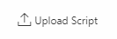
- Fill in the required fields and upload the script.
- Once the script is uploaded click “Run Script” in the upper right corner.

- Click on the “Run” on the upper right corner
- To verify if your script ran fine, click on “Schema” from the menu on the left. You’ll find the tables listed as described below. Take a screenshot that includes your username at the top and paste it into the document below.
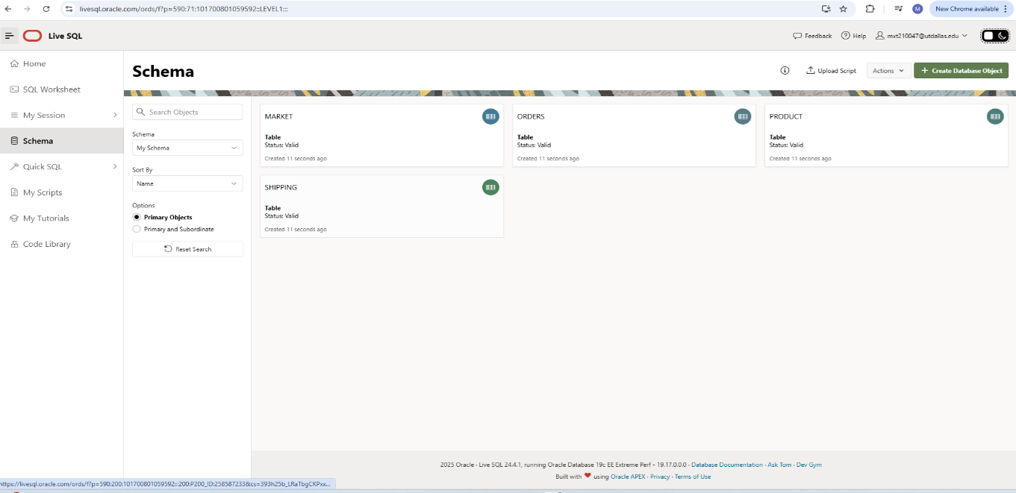

Use the database schema below to understand the relationship of various tables, while identifying primary and foreign keys:
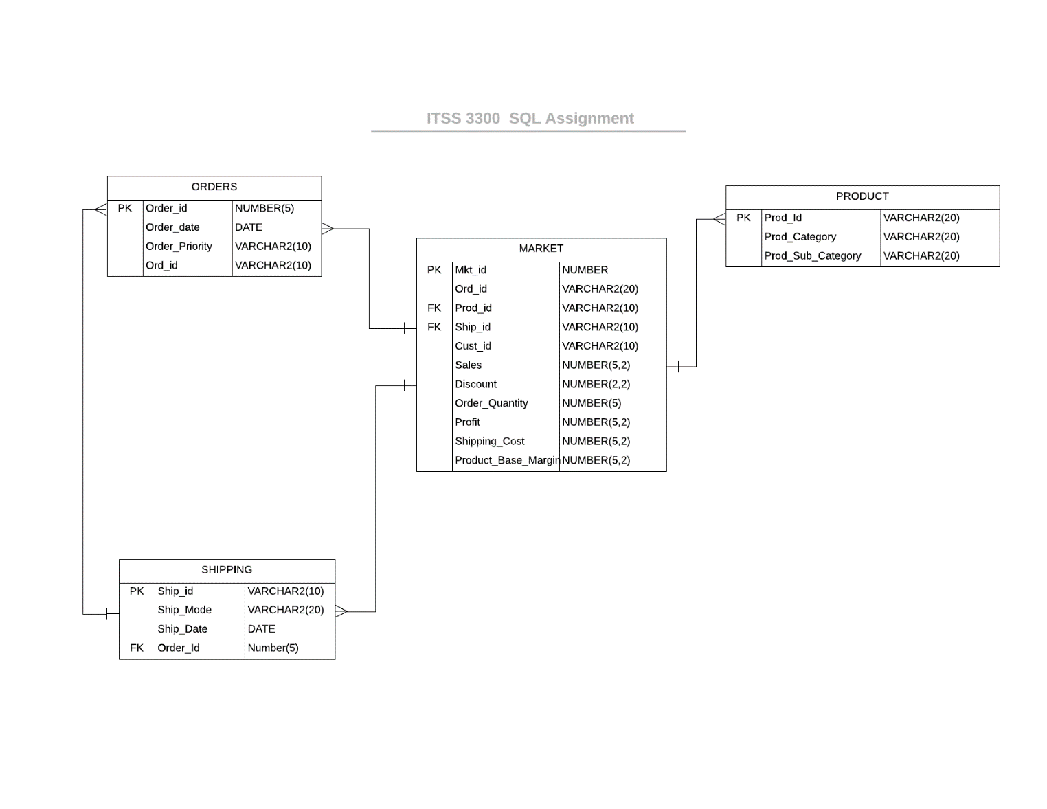

Respond to the questions below. Paste the query and a screenshot of the result for each of the questions. Take the screenshot in a way that the username is captured; e.g: should be

Questions; three (3) points each - You must include a screenshot AND the SQL query in your answer. The screenshot must clearly display your username. 1.5 pts for the screenshot, 1.5 pts for the query. Send this document filled out to john.young@utdallas.edu. Ensure you rename the document with your section, your first initial, last name, and “SQL”; e.g. 501 JYoung SQL.docx. Ensure the subject line of your email references your section number. FAILURE TO FOLLOW THE SUBJECT AND FILE NAMING CONVENTIONS WILL RESULT IN A 3-POINT DEDUCTION.

- List all the different product categories and subcategories in alphabetical order; list only the product category and product subcategory. Sort by the product subcategory.
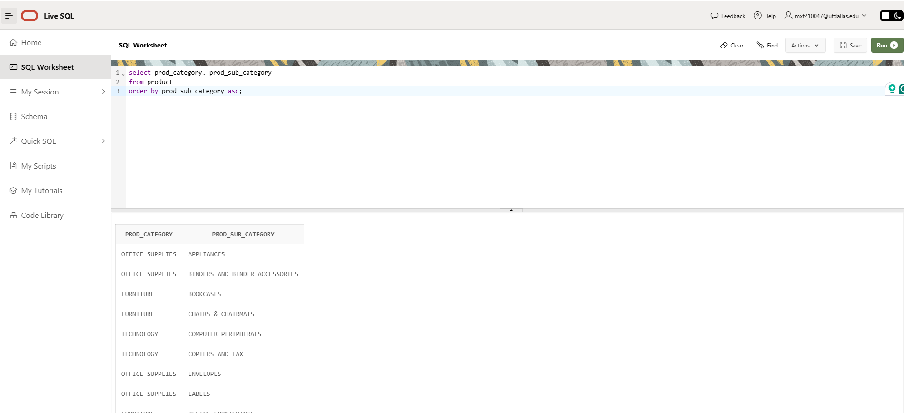

- How many ORDERS had a CRITICAL order_priority? [Hint: you will use the function COUNT(*)].
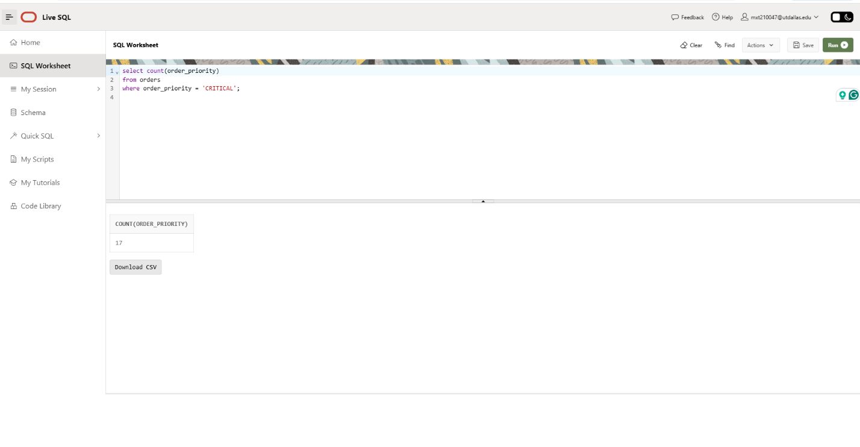
- Display the order date and the ship date for all orders that were made April 1 through April 15. List the order date, ship date, order priority, and ship mode. Order the results by order_date. Do you notice anything unusual about the data? [Hint: You will need to join the orders and shipping together and use a join statement. You will need to limit the result set by the date field order_date <= to_date('04/15/2018', 'mm/dd/yyyy')… take a look at the class slides].
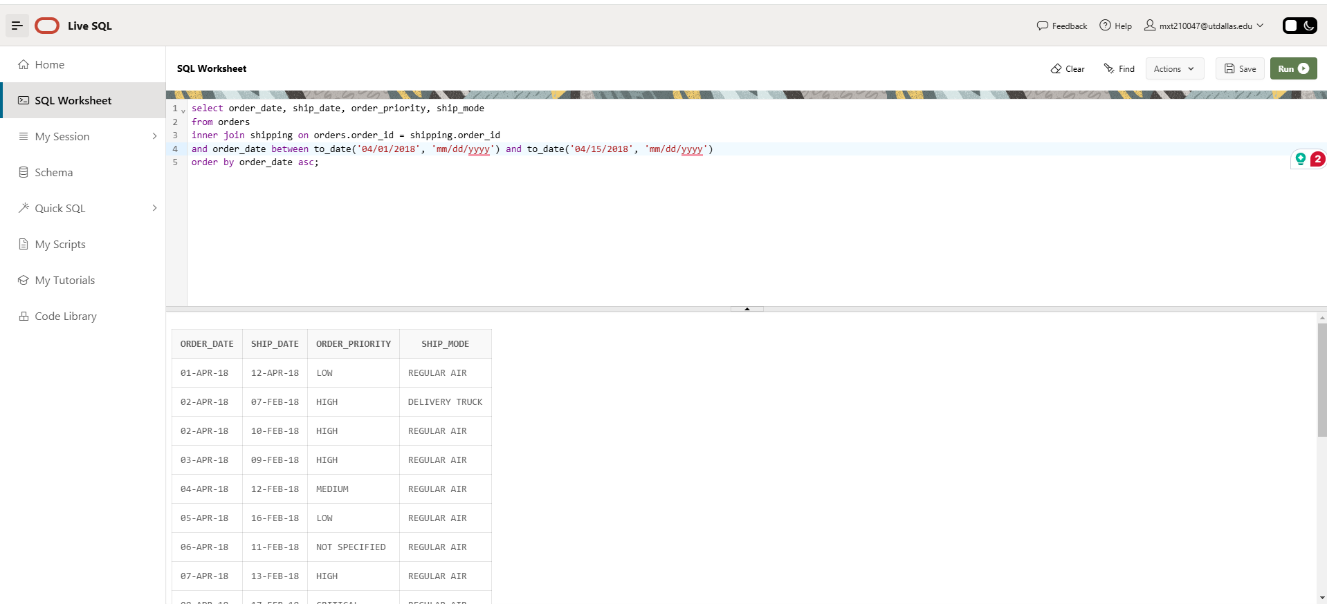

- How much sales and profit were made from the sales of COMPUTER PERIPHERALS (Prod_8)? [Hint: you will use the SUM function you will need a WHERE clause to filter the rows].
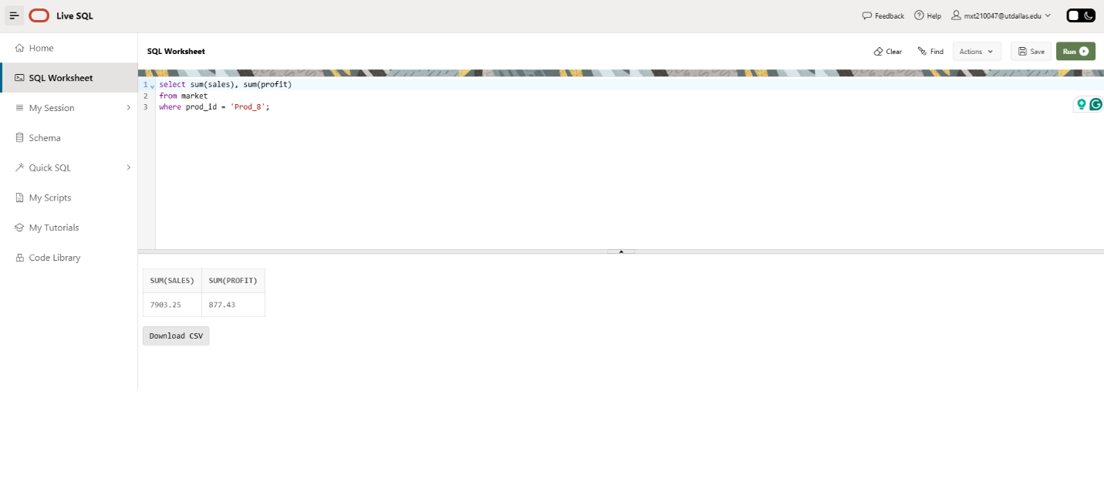

- List the sales, order_quantity, and profit for all products in the TECHNOLOGY category. Display the product subcategory name, the sales, order quantity, and profit. Order by the product subcategory name. [Hint: you will need to join the market and product tables together and filter the rows by product category. You will also need an ORDER BY clause].
